**Reading inputs and storing it in 6 arrays**

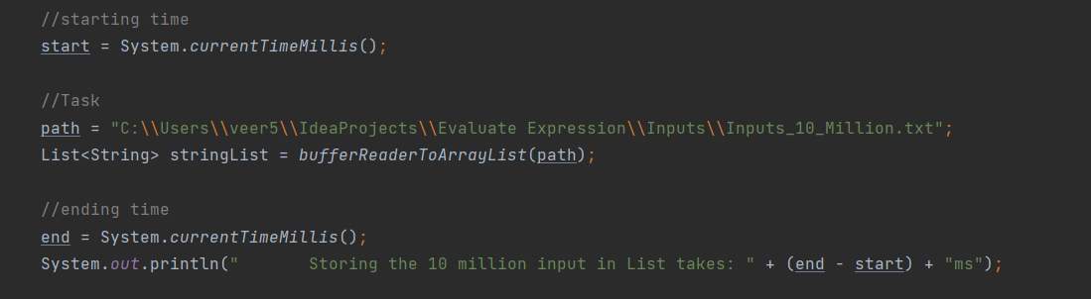

**Output:**

core count: 4

Storing the 10 million input in List takes: **3007ms**

k: 10000000

creating 6 arrays with size 10 million size takes: **116ms**

storing input through char array in 6 different arrays from list with 10 million size takes: **14363ms**

Running ReadInputs takes: **17499ms**

**Storing Data by using 4 threads**  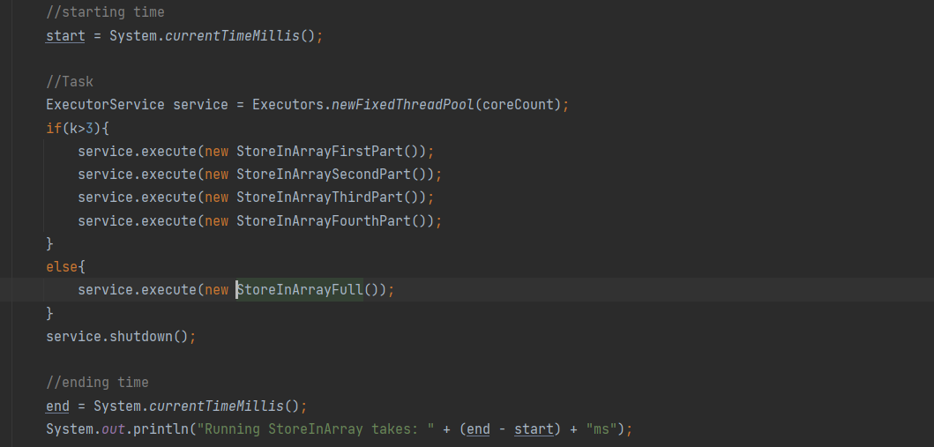

**Output**

core count: 4

Storing the 10 million input in List takes: **3469ms**

k: 10000000

creating 6 arrays with size 10000000 size takes: **94ms**

Running ReadInputs takes: **3578ms**

Running StoreInArray takes: **16ms**

iterateLoopStart: 0 iterateLoopEnd: 2500000

iterateLoopStart: 2500000 iterateLoopEnd: 5000000

iterateLoopStart: 5000000 iterateLoopEnd: 7500000

iterateLoopStart: 7500000 iterateLoopEnd: 9999999

storing input through char array in 6 different arrays from list with 10 million size takes: **8185ms**

storing input through char array in 6 different arrays from list with 10 million size takes: **8451ms**

storing input through char array in 6 different arrays from list with 10 million size takes: **8738ms**

storing input through char array in 6 different arrays from list with 10 million size takes: **8926ms**

**Final Program(Single Threading) Output:**

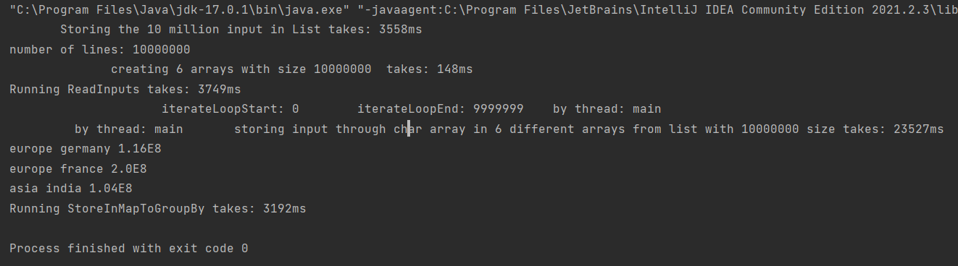

Storing the 10 million input in List takes: **3558ms**

number of lines: 10000000

creating 6 arrays with size 10000000 takes: **148ms**

Running ReadInputs takes: **3749ms**

iterateLoopStart: 0 iterateLoopEnd: 9999999 by thread: main

by thread: main storing input through char array in 6 different arrays from list with 10000000 size takes: **23527ms**

**europe germany 1.16E8**

**europe france 2.0E8**

**asia india 1.04E8**

Running StoreInMapToGroupBy takes: **3192ms**

**Output by using Multithreading**

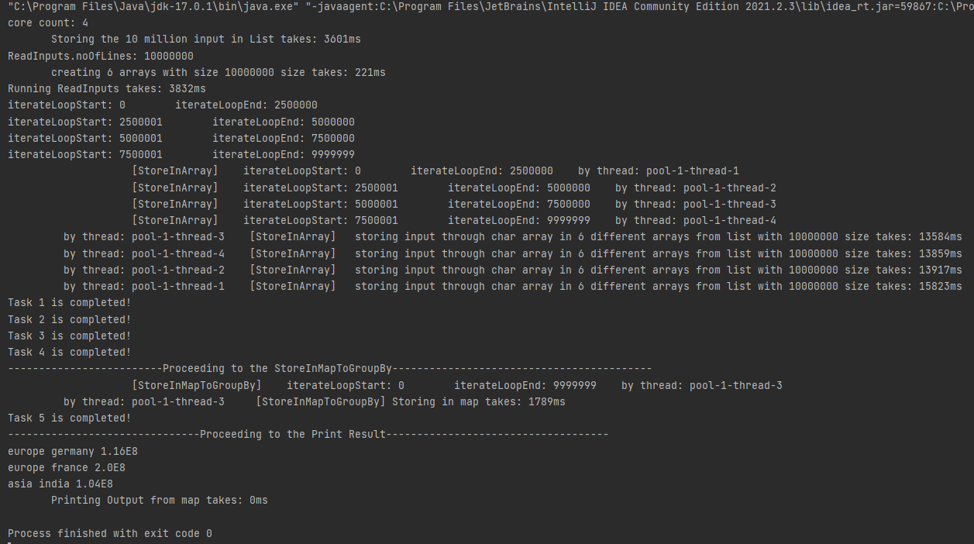

core count: 4

Storing the 10 million input in List takes: **3601ms**

ReadInputs.noOfLines: 10000000

creating 6 arrays with size 10000000 size takes: **221ms**

Running ReadInputs takes: **3832ms**

iterateLoopStart: 0 iterateLoopEnd: 2500000

iterateLoopStart: 2500001 iterateLoopEnd: 5000000

iterateLoopStart: 5000001 iterateLoopEnd: 7500000

iterateLoopStart: 7500001 iterateLoopEnd: 9999999

[StoreInArray] iterateLoopStart: 0 iterateLoopEnd: 2500000 by thread: pool-1-thread-1

[StoreInArray] iterateLoopStart: 2500001 iterateLoopEnd: 5000000 by thread: pool-1-thread-2

[StoreInArray] iterateLoopStart: 5000001 iterateLoopEnd: 7500000 by thread: pool-1-thread-3

[StoreInArray] iterateLoopStart: 7500001 iterateLoopEnd: 9999999 by thread: pool-1-thread-4

by thread: pool-1-thread-3 [StoreInArray] storing input through char array in 6 different arrays from list with 10000000 size takes: **13584ms**

by thread: pool-1-thread-4 [StoreInArray] storing input through char array in 6 different arrays from list with 10000000 size takes: **13859ms**

by thread: pool-1-thread-2 [StoreInArray] storing input through char array in 6 different arrays from list with 10000000 size takes: **13917ms**

by thread: pool-1-thread-1 [StoreInArray] storing input through char array in 6 different arrays from list with 10000000 size takes: **15823ms**

Task 1 is completed!

Task 2 is completed!

Task 3 is completed!

Task 4 is completed!

-------------------------Proceeding to the StoreInMapToGroupBy------------------------------------------

[StoreInMapToGroupBy] iterateLoopStart: 0 iterateLoopEnd: 9999999 by thread: pool-1-thread-3

by thread: pool-1-thread-3 [StoreInMapToGroupBy] Storing in map takes: **1789ms**

Task 5 is completed!

-------------------------------Proceeding to the Print Result------------------------------------

**europe germany 1.16E8**

**europe france 2.0E8**

**asia india 1.04E8**

Printing Output from map takes: **0ms**